*C:\Users\mlingafelter\AppData\Local\Microsoft\Windows\Temporary Internet Files\Content.IE5\FK9ZEVH6\MC900438203[1].wmf*

C:\Users\mlingafelter\AppData\Local\Microsoft\Windows\Temporary Internet Files\Content.IE5\FK9ZEVH6\MC900438203[1].wmf

**Steele School January 2013**

[**mlingafelter@galesburg205.org**](mailto:mlingafelter@galesburg205.org)

**phone- 309-343-0516**

**Fax- 309-343-1259**

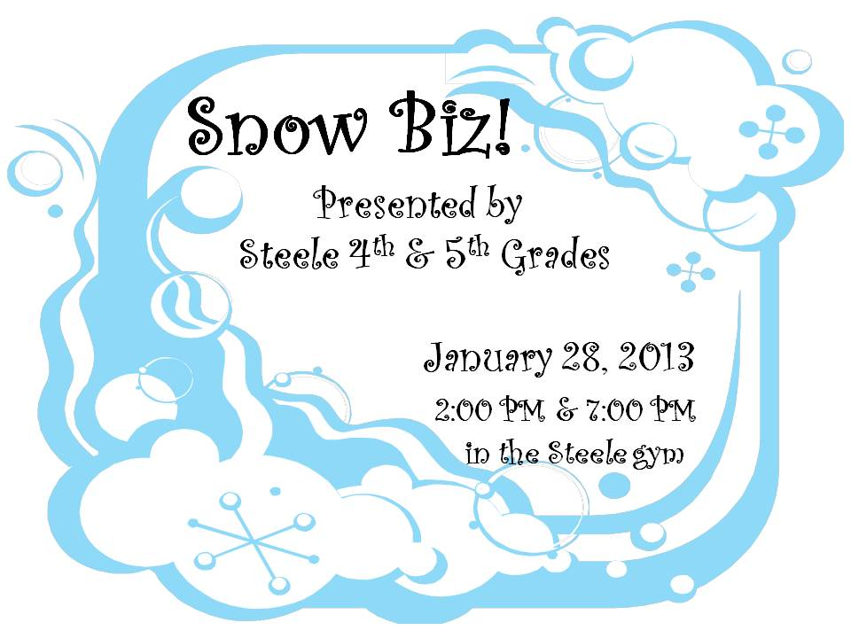

**Attendance Information:**

**For more details check out the link**

**on our school website at:**

[**http://steele205.weebly.com/attendance.html**](http://steele205.weebly.com/attendance.html)

**Tardy Students:**

Be reminded that students may be at school at 8:20 a.m. Students entering the classroom after 8:45 a.m. are considered tardy and are subject to our tardy policies which include loss of recess and after school detentions.

**When your child is absent or late…**

Please, call the office (343-0516) by 9:00 am to report your child’s absence each day they are gone from school. It is Illinois State Law. An absent child, with no call or notice from you is a major concern for the school staff – Did the child leave for school but did not make it?

**Doctor/Medical Appointments:**

It is District #205’s policy that if a student is absent from school because of a medical appointment they will need to have a physician’s note turned in to the school in order for the student to receive an excused absence. If a physician’s note is not received, the student will be marked for an unexcused absence. Thank You.

**Calendar Highlights:**

December 21st – January 6th Winter Break

January 7th – School Resumes

January 7th – PTO Meeting 5:30 pm

January 11th – Report Cards Distributed

January 14th – Board of Education Meeting 7:00 pm

January 16th – 2:20 Early Dismissal

January 21st – No School: Martin Luther King Jr.

January 28th – Fourth/ Fifth Grade Musical 7:00 pm

January 31st – Box Tops January Turn-in Date

February 1st – End of Third Quarter Mid-Term

February 2nd – Knox County Geography Bowl

**Emergency Phone Numbers**

Please insure that we have at least two contact numbers for you in case of an emergency. This is very important that we always have current phone/ cell phone numbers throughout the school year. If you are unsure about your emergency contact information or have made changes to your number please contact us at 343-0516 as soon as possible.

**…Helping Students Achieve Their Dreams…**

C:\Users\mlingafelter\AppData\Local\Microsoft\Windows\Temporary Internet Files\Content.IE5\TB61HJYQ\MC900038626[1].wmf

**Canned Food Drive**

WOW…What a GREAT JOB our

Steele Superstars did in our canned

food drive. We collected over 1,400

non-perishable food items during our

10 day canned food drive. Students also met Mr. Lingafelter’s Monday challenge of having 25 cents donated for each item brought in. On that Monday students brought in 288 food items. This allowed Mr. Lingafelter to donate $72 to the FISH food pantry. The canned food drive exceeded our expectations and the staff of Steele School would like to thank you for your generosity!

**Student Council:**

The next activity that our student council will be involved in is the Carl Sandburg Penny Drive. Please start saving up your pennies as we will have a Penny Challenge after Winter Break.

**Changes to ISAT cut scores:**

ISBE plans to significantly raise cut scores for the reading, math, and science test scores. These changes will make it more difficult for our students to be identified in the “Exceeds Standards” or “Meets Standards” category. This shift is to help us realize the rigor that is going to be necessary as we transition from the ISAT test to the new PARCC assessment.

***Steele School Winter Playground Policy***

We will go outside under these guidelines:

* If the temperature is 20 degrees or higher, or if the wind chill factor is not below 20 degrees
* When we have snow cover, students without boots will not be allowed off the blacktop area
* If your child should remain indoors due to an illness, you may send a note. If it is for an extended period of time, we reserve the right to ask for a doctor’s note.
* Remember to wear your coat!

**Construction Project:**

The good weather that we have

had allowed the Iron Workers to put

up the shell of the gym. The roof for the gym is also installed. They are now working on the exterior stud walls. Over winter break the iron beams that connect the gym with the existing building will arrive and begin being installed. At the January 7th PTO meeting Mr. Lingafelter will give an updated account of the project. All are welcome to attend!

We have added a link to our website that holds a variety of pictures related to the work being done. The link is:

<http://steele205.weebly.com/construction-update.html>

**School Safety:**

As we are undergoing construction there are many measures we have put in place to maintain school safety. Each worker who comes on school grounds to work undergoes a mandatory background check. After the background check is complete we have a system in place that allows all staff members to know that the workers have been approved by the Regional Office of Education. If you have any questions or concerns related to the construction project please contact the office. (more information related to school safety is on the next page)

**Treats/ Snacks:**

A reminder: All treats must be store bought and pre-packaged with nutritional information listed. No homemade treats or items from any bakeries are allowed for distribution at school. We also do not have refrigeration space for snacks. Thank You!

**…Helping Students Achieve Their Dreams…**

**School Safety**

**Parking Lot:**

Student safety is our biggest concern with our parking lot. For your child’s safety we have made it mandatory for cars to park both before and after school in a parking space. We also have established marked crosswalks that students must use to get to and from your vehicle. We at times still have students and parents walking behind cars and this is a major safety concern. Please take your time in the parking lot and use the designated crosswalks.

**Bus Lane:**

Please be reminded that the driving lane along the south side of the parking lot is for buses only. Our buses run on very tight schedules district wide and they must be able to use the bus lane without other vehicles blocking it. Reminder: Passing a bus with the Stop Arm out is illegal and comes with a very expensive fine.

**Safety Drills:**

Each year we conduct a variety of safety drills with and without students. State Code states that each school must do at least three fire drill evacuations, one bus evacuation drill, a Law enforcement drill, and a severe weather drill. This code is the minimum that each school must comply with. At Steele we do more than the minimum to insure that all students and staff are fully aware of our procedures. If you have questions or concerns about our policies please contact the school office.

**Construction Project:**

Part of our new construction is increasing the level of security features in place for our students’ and staffs’ safety. The architects, construction manager, and administration are continually reviewing the safety plans and making sure the level of security is appropriate. These plans are also reviewed with trained officials and first responders for any adjustments that are needed.

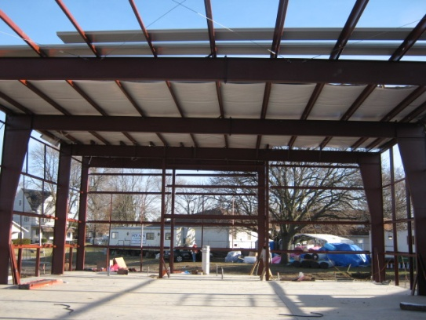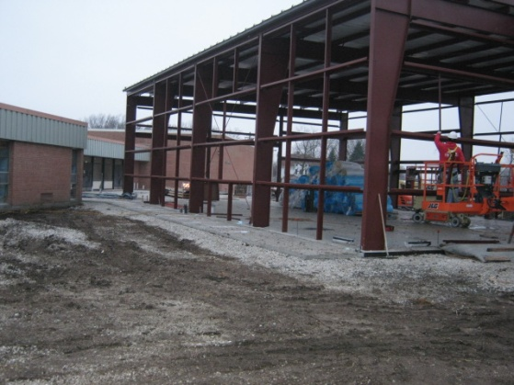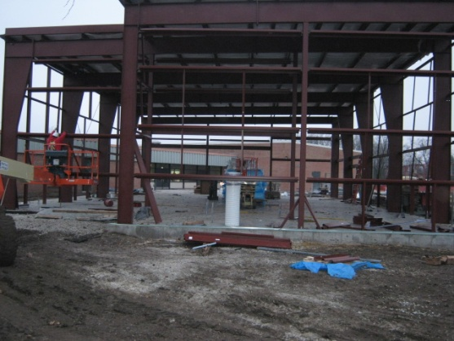

**Steele School Musical needs your help!**

**Mrs. Fox is in need of the following items to make the musical possible:**

Parkas/Outerwear Coats with fur trim around the hoods (Could even be adult sizes), Rubber boots or waders, Light blue shirts (that Postal workers would wear), Navy blue pants (Kids sizes or small adult – male or female), Ski pants, Ski jackets, Ski gloves, Ski poles, Skis, Ski goggles, Snowboard pants, Snowboard coats, Snowboard gloves, Snowboards, “Loud” plaid or striped pants or Sport coats, Wool scarves, Wool mittens, Fake fruit and vegetables, Hockey sticks, Snowmen (Free standing), Anything that would be “snow” related clothing (Scarves, etc.)

Mrs. Fox needs these items immediately following Winter Break at the latest. If it would be possible to borrow them before that, that would be great. She would need them until the end of January. Please clearly label anything that is brought in with your child’s name.

**…Helping Students Achieve Their Dreams…**

|  |  |  |  |  |
| --- | --- | --- | --- | --- |
| MONDAY | **TUESDAY** | **WEDNESDAY** | **THURSDAY** | **FRIDAY** |
|  | **1**  **WINTER BREAK** | **2**  **WINTER BREAK** | **3**  **WINTER BREAK** | **4**  **WINTER BREAK** |
| **7**  **SCHOOL RESUMES**  PTO Meeting  5:30 (Library) | **8** | **9**  4th & 5th Grade Musical Rehearsal 9:45 – 11:00 | **10** | **11**  Report Cards Distributed |
| **14**  4th & 5th Grade Musical Rehearsal 9:45 – 11:00 | **15**  Brownies  3:15 – 4:30 | **16**  **Early Dismissal @ 2:20** | **17** | **18** |
| **21**  **No School**  **Martin Luther King Holiday** | **22**  4th & 5th Grade Musical Rehearsal  9:45 – 11:00  4th & 5th Girls Choir Rehearsal | **23** | **24** | **25** Young Author Books Due  4th & 5th Grade Musical Rehearsal 9:45 – 11:00  4/5 Boys Choir Rehearsal/Lunchtime |
| **28**  **Musical**  **“Snow Biz”**  **4th & 5th Grade**  IMG_2076.JPG**2:00 & 7:00** | **29**  Brownies  3:15 – 4:30 | **30** | **31**  4th & 5th Grade Girls Choir Rehearsal | **Note:**  **Saturday, Feb. 2nd**  **The Knox County Geography Bowl will be held.** |

MC900438203[1]

Steele School

Phone: 343 0516

Fax: 343 1259

Cafeteria: 343 4975

Principal: Matt Lingafelter

Email: mlingafelter@galesburg205.org

Steele School January 2013

**…Helping Students Achieve Their Dreams…**